SOFTWARE REQUIREMENTS SPECIFICATION (SRS)

AgileAI – Hybrid Agile–AI Project Management Platform

1. Introduction

1.1 Purpose
This document specifies the software requirements for AgileAI, a Hybrid Agile–AI Project Management Platform. The purpose of this system is to integrate traditional Agile project management practices with Artificial Intelligence (AI)–based decision support mechanisms to improve sprint planning, risk prediction, and team performance analysis.
This SRS document is intended for project stakeholders, developers, project evaluators, and system architects.

1.2 Scope
AgileAI is a web-based project management system developed using the MERN stack (MongoDB, Express.js, React.js, Node.js) integrated with Machine Learning models.
The system will allow users to:
- Create and manage projects and sprints
- Manage backlog and task assignments
- Track task progress and work logs
- Generate sprint analytics and performance metrics
- Predict sprint risks using AI
- Estimate effort and sprint capacity
- Provide explainable AI insights
The system aims to enhance decision-making in Agile environments through intelligent data-driven insights.

1.3 Definitions, Acronyms, and Abbreviations
- AI – Artificial Intelligence
- ML – Machine Learning
- SRS – Software Requirements Specification
- DFD – Data Flow Diagram
- MERN – MongoDB, Express, React, Node
- API – Application Programming Interface
- RBAC – Role-Based Access Control

2. Overall Description

2.1 Product Perspective
AgileAI is a standalone web application that integrates with a backend AI module.
The system consists of:
- Frontend (React.js)
- Backend API (Node.js + Express)
- Database (MongoDB)
- AI/ML Engine (Python-based ML services or integrated ML APIs)
The system interacts with three main actors:
- Admin
- Project Manager
- Developer

2.2 Product Functions
The major functions of the system include:

Administrative Functions
- User registration and login
- Role management (Admin, PM, Developer)
- System monitoring and reports

Project Management Functions
- Create, edit, delete projects
- Create and manage sprints
- Manage backlog
- Assign tasks to developers
- Track task progress
- Log work hours

AI-Based Functions
- Sprint risk prediction
- Effort estimation
- Sprint capacity prediction
- Team performance analysis
- Explainable AI insights (feature importance, reasoning)

2.3 User Classes and Characteristics

1. Admin
- Technical knowledge: Moderate
- Responsibilities: User management, system oversight

2. Project Manager
- Technical knowledge: Moderate to High
- Responsibilities: Sprint planning, task assignment, monitoring AI insights

3. Developer
- Technical knowledge: Moderate
- Responsibilities: Task updates, logging work hours

2.4 Operating Environment
- Web browser (Chrome, Firefox, Edge)
- Server environment (Node.js runtime)
- MongoDB database server
- AI module running on Python (scikit-learn / ML libraries)

2.5 Design and Implementation Constraints
- Must use MERN stack
- AI models must provide explainable outputs
- System must support role-based access control
- Must be deployable on cloud platforms

2.6 Assumptions and Dependencies
- Users have internet access
- Historical sprint data is available for AI model training
- MongoDB database is properly configured

3. System Features and Functional Requirements

3.1 User Authentication

Description
The system shall allow users to securely log in and access features based on their role.

Functional Requirements
FR-1: The system shall allow users to register.
FR-2: The system shall authenticate users using email and password.
FR-3: The system shall implement role-based access control.

3.2 Project Management
FR-4: The system shall allow Project Managers to create projects.
FR-5: The system shall allow creation of sprints within projects.
FR-6: The system shall allow adding tasks to backlog.
FR-7: The system shall allow task assignment to developers.
FR-8: Developers shall update task status (To Do, In Progress, Done).

3.3 Sprint Analytics
FR-9: The system shall calculate sprint velocity.
FR-10: The system shall display burndown charts.
FR-11: The system shall compute task completion rate.

3.4 AI Risk Prediction
FR-12: The system shall analyze sprint metrics to predict risk levels.
FR-13: The system shall classify sprint risk as Low, Medium, or High.
FR-14: The system shall display probability score of failure.

3.5 Effort Estimation
FR-15: The system shall predict task effort based on historical data.
FR-16: The system shall estimate sprint completion probability.

3.6 Explainable AI
FR-17: The system shall display key factors contributing to risk prediction.
FR-18: The system shall provide human-readable explanations.

4. External Interface Requirements

4.1 User Interface
- Responsive dashboard
- Visual charts (burndown, velocity)
- AI insights panel
- Role-based navigation

4.2 Hardware Interface
No special hardware requirements.

4.3 Software Interface
- MongoDB database
- RESTful APIs
- ML service API

5. Non-Functional Requirements

5.1 Performance Requirements
- System response time must be less than 3 seconds.
- AI predictions must be generated within 5 seconds.

5.2 Security Requirements
- Password encryption using hashing.
- JWT-based authentication.
- Role-based access control.

5.3 Usability Requirements
- Easy navigation dashboard
- Clear AI explanation display
- Minimal training required

5.4 Reliability
- System availability of 95% uptime
- Proper error handling

5.5 Scalability
- System must support at least 500 concurrent users.

6. Future Enhancements
- Integration with Jira and GitHub
- Real-time AI adaptive sprint suggestions
- AI chatbot for project insights
- Cross-project predictive analytics

7. Conclusion

AgileAI aims to bridge the gap between traditional Agile project management and intelligent AI-driven decision support systems. By integrating predictive analytics, effort estimation, and explainable AI insights into sprint workflows, the system enhances decision-making, reduces project risks, and improves sprint success rates.

8. DFD Diagram
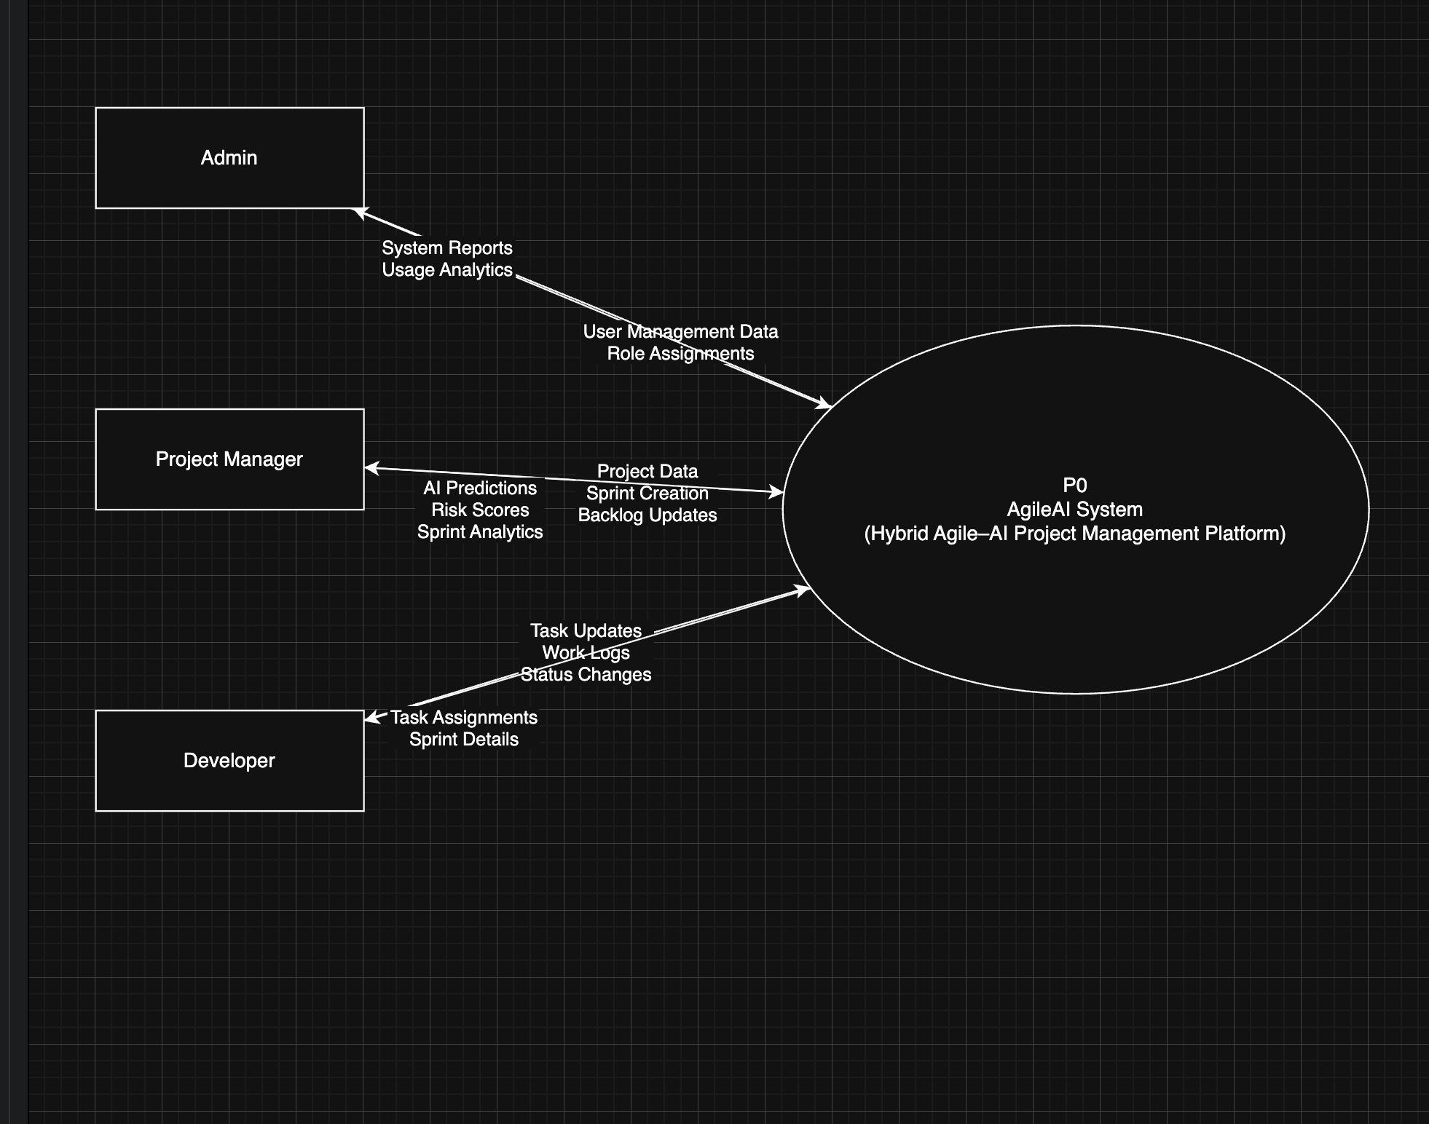

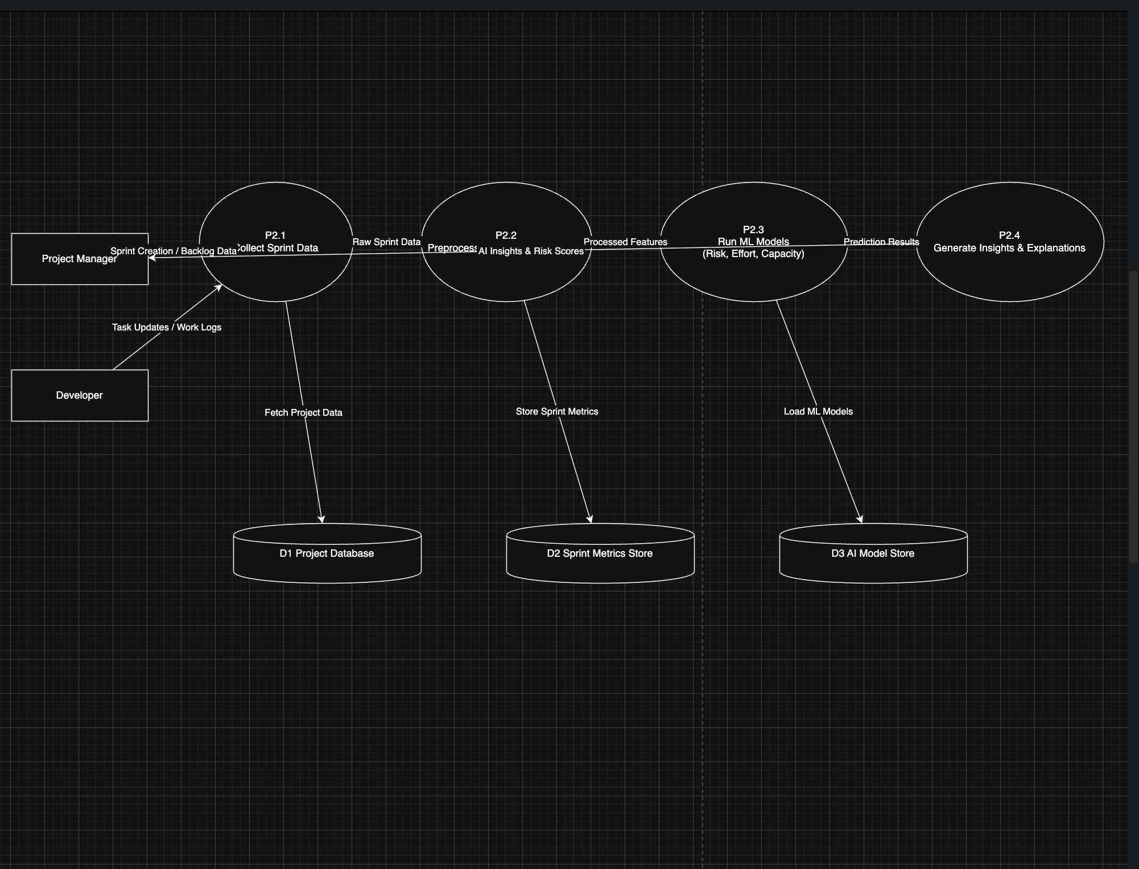

9. Use Case Diagram

